**Lab 2**

Name: Swapnil Sevak

Student ID: C0777195

1. Create a 2D plot of the sine function between 0 and 2π.

Code:

X= 0:0.1:2*pi;

plot(X, sin(X));

Output:

1. Create a 3D plot of a surface by creating a grid along the X and Y axes and plotting the Z-coordinate according to the exponential function.

Code:

[x, y, z] = meshgrid (1:5, 1:5, 1:5);

v = rand (5, 5, 5);

isosurface (x, y, z, v, .5);

Output:

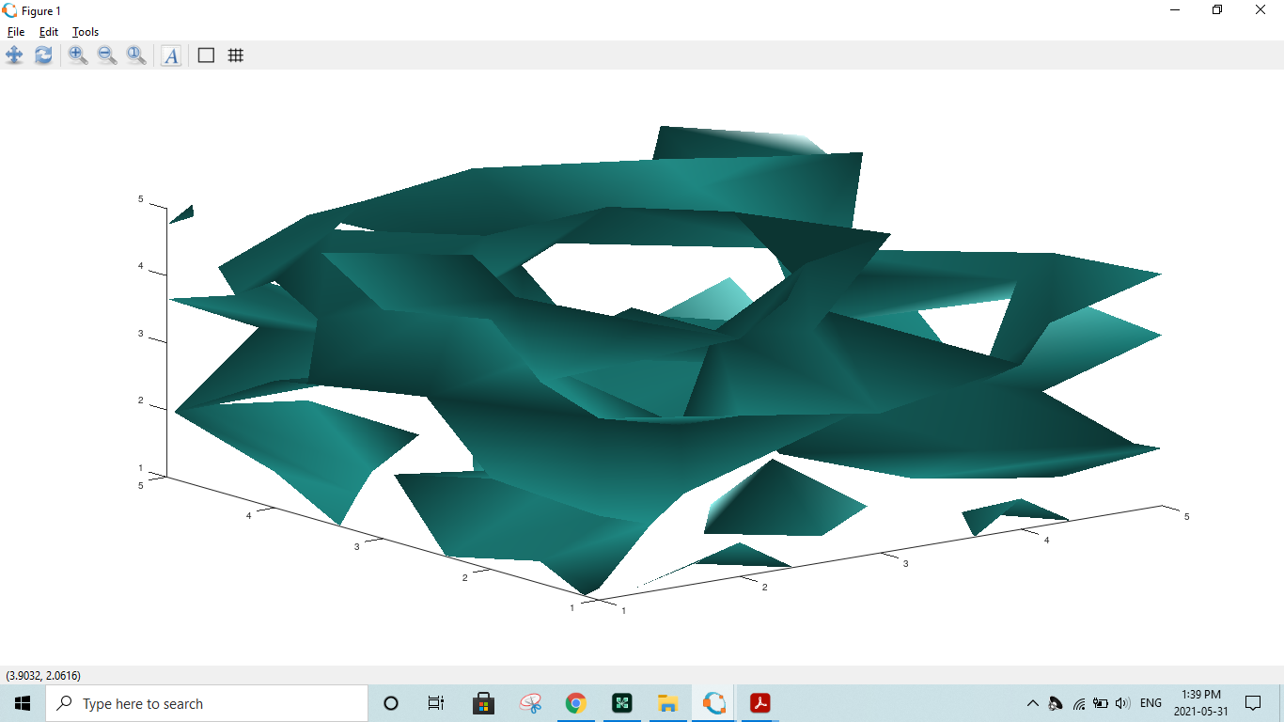

1. Write a script to apply if and if-else statements.

Code:

* For if statement script will be;

If (condition)

Then body

Endif.

* For if else statement script will be;

If (condition)

Then body

Else

Else body

Endif.

1. Write a script to apply conditional logic switch.

Code:

a = randi(100, 1);

if a < X

disp('small')

elseif a < Y

disp('medium')

else

disp('large')

end

1. Write a script to perform loop with a while condition.

Code:

n = 5;

f = n;

while n > 1

n = n-1;

f = f*n;

end

disp(['n! = ' num2str(f)])

1. Write a script to plot a vector of random data. Draw a horizontal line at the mean. Save the script and run it from the command line.

Code:

n = 100;

r = rand(n,1);

plot(r)

m = mean(r);

hold on

plot([0,n],[m,m])

hold off

title('Mean of Random Uniform Data')

Output:

7. Write a script that calculates the mean of five samples of data from a vector of random data. Calculate the overall mean. Use a for loop to perform the calculations. For each iteration of the loop print out the intermediate results. Use an if..else control block to display the results

depending on whether the mean of the samples is less than, greater than or equal to the overall mean.

Code:

A=rand(100,1);

sum1=0;

for i=1:length(A)

sum1=sum1+A(i);

end

M=sum1/length(A);

sum2=0;

for i=1:length(A)

sum2=sum2+ (A(i)-M)^2;

end

1. Create a function that calculates the area of a circle with the radius as input in command window. Call this function from the MATLAB command line or in a MATLAB script (.m).

Answer:

prompt = 'What is the original value? ';

x = input(prompt)

area = pi*x*x;

Output:

9. Create a function that calculates the sum of an arbitrary number of sinusoidal terms. Call this function from the MATLAB command line or in a MATLAB script (.m).

Code:

Fs = 60;

Ts = 1/60;

t = 0:Ts:30

x1 = 1*cos(2*pi*.73*t+pi/3);

x2 = 1*cos(2*pi*1.33*t-pi/4);

x3 = 1*cos(2*pi*1.93*t+pi/5);

x4 = 1*cos(2*pi*2.93*t-pi/6);

x = x1 + x2 + x3 + x4;

figure(2)

subplot(5,1,1)

h = plot(t,x1); box off; grid off

xlabel('Time(s)');

ylabel('Amplitude');

subplot(5,1,2)

h = plot(t,x2); box off; grid off

xlabel('Time(s)');

ylabel('Amplitude');

subplot(5,1,3)

h = plot(t,x3); box off; grid off

xlabel('Time(s)');

ylabel('Amplitude');

subplot(5,1,4)

h = plot(t,x4); box off; grid off

xlabel('Time(s)');

ylabel('Amplitude');

subplot(5,1,5)

h = plot(t,x); box off; grid off

xlabel('Time(s)');

ylabel('Amplitude');

Output:

